[Course Title]

[overview of what this document is and one sentence on what the course is/was]

Click below to jump throughout the document
- Construction of the Course
- Elements of the Course

NOTE: This training documentation is based on Cennamo and Kalk’s Spiral Model, a balanced approach between ADDIE and Agile methodologies. One key to this approach is the trend towards clarity: all components are touched on in each phase, but each becomes more defined along the way. This training documentation was designed by Brady Licht under CC BY-NC-SA.

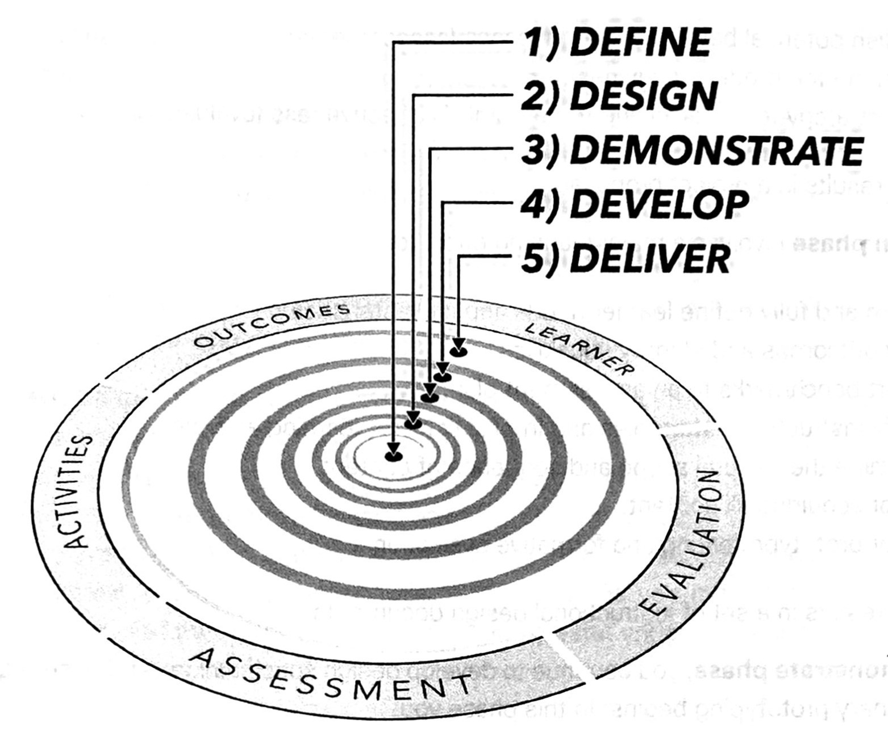

Construction of the Course

Define

Training Needs
[Why does the training need to occur? What is the problem that this training will solve? What research is there to support this claim?]

Instructional Goal(s)
[What is the big goal/intention? This is stakeholder-facing as opposed to participant-facing. This is not a list of learning objectives. This should be no more than three sentences.]

Target Audience Characteristics
[What do we know about the audience–surveys, general research, and client data?]

Pre-Design Course Vision
[What are you currently envisioning that the course will look like? This should be no more than a single paragraph description.]

Requirements & Construction
[What are the resources that have to be used (if any)? Is there a cost associated with anything? How many hours/days will it take to build and deploy?]

Design

Learning Objectives
[What are the specific outcomes? This is participant-facing. This should include roughly 3-8 major outcomes. These outcomes can be then divided into specific lesson outcomes or success criteria. These criteria will inform the rubrics of any future assessments.]

Training Components/Formats
[What are the formats or larger components that may work well for this training?]
- Microlearning
- Independent Study
- Research Project
- Asynchronous, Online Course
- Remote Workshop
- Book Study
- Coaching
- Conference
- In-Person Workshop

Instructional Strategies
[This should include any broad strategies and approaches. Why are these broad strategies and approaches appropriate? What does the research show? Link to research when possible. Additionally, feel free to use the table below for ideas.]

Optional Tool: Visible Learning Strategies
[To use this, simply check off the boxes of the strategies that you plan to use and explain your early idea of how you could use it. To save space, delete unnecessary rows when you are all done]
Common Visible Learning Meta X / Hattie Training Strategies
 | Strategy (Click here for strategy definitions) | Effect Size | How are are you currently thinking of using it?
 | Jigsaw Method | 1.2
 | (Teacher) Credibility | 1.09
 | Integrate Knowledge | 0.93
 | Success Criteria | 0.88
 | Video Review | 0.88
 | (Teacher) Clarity | 0.84
 | Classroom Discussion | 0.82
 | Mnemonics | 0.8
 | Deliberate Practice | 0.79
 | Planning & Prediction | 0.76
 | Reflection | 0.75
 | Help Seeking | 0.72
 | Summarizing | 0.71
 | Self-Directed Learning | 0.67
 | Spaced Practice | 0.65
 | Concept Mapping | 0.64
 | Vocabulary | 0.63
 | Feedback | 0.62
 | Metacognition | 0.6
 | Direct Instruction | 0.59
 | Interactive Video | 0.58
 | Group Cohesion | 0.53
 | Clear Goal Inentions | 0.51
 | Imagery | 0.51
 | Note-taking | 0.51
 | Peer Tutoring | 0.51
 | Questioning | 0.49
 | Small Group Learning | 0.47
 | Differentiation | 0.46
 | Practice Testing | 0.46
 | Interleaved Practice | 0.44
 | Peer Assessment | 0.44
 | Underlining | 0.44
 | Advance Organizers | 0.42
 | Virtual Reality | 0.42
 | Gaming / simulations | 0.41
 | Goal Commitment | 0.4
 | Collaborative Learning | 0.39
 | Worked Examples | 0.37
 | Audiovisuals | 0.36
 | Tactile Stimulation | 0.36
 | PBL (Problem) | 0.35
 | Learning Styles | 0.34
 | Webinars | 0.33
 | Use of PowerPoint | 0.26
 | Individual Instruction | 0.24
 | Co- / team teaching | 0.19
 | Coaching | 0.18
 | Mentoring | 0.12
 | Humor | 0.04

Initial Design Document
Complete a early “map” of the course. This should include the 1) order in which things appear, 2) the outcomes/success criteria, 3) the assessments, 4) the activities, and 5) any readings. For each, you just need a couple words or a short phrase. You are not building any of these at this time. You may want to consider making a flowchart or action map to represent the course. Make sure to embed or link the design document below. If you design it on paper or on a whiteboard, take a picture of it and embed or link it below.

Optional Tool: Color-Table Course Chart
[This item is completed from left to right and provides an overview of how the pieces will fit together. Cells can be merged in assessments, activities, and readings to show that they cover multiple success criteria. Cells can be merged across assessments, activities, and readings if something is both an assessment, activity, and reading (such as a research project). You can also create this in a new Doc or Sheet and simply link to it here instead.]
Outcomes | Success Criteria | Assessments | Activities | Readings | Optional Readings / Invitations to Learn More

Demonstrate

Prototyping
[Link to early prototype document. This may include one or two partially completed modules or lessons to test. This should be built in Docs or Slides rather than the LMS in order to make it easy to share. This is also your opportunity to start chunking the content from the design document: some items can be on the same page or some items need to be across multiple pages. This is to help you get an idea of “what it will look like”]

Reviews & Testing
[How will you have the prototype (and possibly the design document) reviewed and/or tested? How do you know this is the most effective way to have it reviewed? Will this require different tiers of review? After you have shown it to them, what input did they provide? If able, how will you test it with a sample participant? How do you know this is the most effective way to have it piloted? Will it be one-on-one, small group, etc? After and while they are piloting it, what have you learned?]

Revisions
[What changes did you make as a result of the reviews and tests? You may want to make a new copy of any sections above if there are major changes (such as in the design document).]

Develop

Learning Resources
[What resources have to be created for the training? What videos, graphics, and audio needs to be developed? What can be sourced rather than created? If it needs to be purchased, how much it is, and why is it critical? How will you keep track of all the course documents, graphics, videos, and surveys? Will you use Google Drive? If so, include a link to it here]

Pre-Implementation Course
[Before uploading it to the LMS, make a pre-implementation version of the course. This is typically an extended Doc with assignment instructions and pages fully written out. This version may have bracketed sections or placeholders indicating where learning resources will be embedded in the final version. Ideally, there would not be many changes between this version and what ultimately is delivered on the LMS. You may use the same document as in the prototype and simply build on it. If so, make a note back by the prototype section of this documentation. Include a link to the pre-implementation course here.]

Additional Review (Optional)
[If time, you may want an additional round of reviews and testing at this point. Document the process and any findings here if you do an additional round.]

Revisions
[While developing the pre-implementation course, what changes did you make? What needed to be tweaked from the original plans? You may want to make a new copy of any sections above if there are major changes (such as in the design document).]

Deliver

Build Course in LMS
[Copy and paste materials from the pre-implementation course into LMS. Add in resources where indicated. Clean up formatting to match the style guide. Add in the course overview page, home page, and any other LMS details. Include a link to the LMS course here.]

Prepare Course
[What do you need to do before the course is ready? Check to make sure that links are working properly. Check for spelling errors. Take time to do a “click-through” of the course to make sure that it all looks good. Write and add a course syllabus and instructor bio. Send out a request to have the course set up for credit. If someone else is facilitating the course, write a facilitation guide. Link the course syllabus here. If necessary, link any additional welcome materials and/or facilitator’s guide.]

Optional Tool: Evaluation Document
[Use this eval document to check if you missed anything]

Course Backup
[Once it all looks good, download a copy of the course package and save it to your drive. Link the course package here.]

Elements of the course
[This is an optional section to allow people to see elements of the course without needing access to the LMS. Typically, the placeholder images are replaced with screenshots of the implemented, published course.]

[course Element - ex: homepage, assessment, discussion]
[description of course element - Lorem ipsum dolor sit amet, consectetur adipiscing elit, sed do eiusmod tempor incididunt ut labore et dolore magna aliqua. Ut enim ad minim veniam, quis nostrud exercitation ullamco laboris nisi ut aliquip ex ea commodo consequat. Duis aute irure dolor in reprehenderit in voluptate velit esse cillum dolore eu fugiat nulla pariatur. Excepteur sint occaecat cupidatat non proident, sunt in culpa qui officia deserunt mollit anim id est laborum.]



[course Element - ex: homepage, assessment, discussion]
[description of course element - Lorem ipsum dolor sit amet, consectetur adipiscing elit, sed do eiusmod tempor incididunt ut labore et dolore magna aliqua. Ut enim ad minim veniam, quis nostrud exercitation ullamco laboris nisi ut aliquip ex ea commodo consequat. Duis aute irure dolor in reprehenderit in voluptate velit esse cillum dolore eu fugiat nulla pariatur. Excepteur sint occaecat cupidatat non proident, sunt in culpa qui officia deserunt mollit anim id est laborum.]

[course Element - ex: homepage, assessment, discussion]
[description of course element - Lorem ipsum dolor sit amet, consectetur adipiscing elit, sed do eiusmod tempor incididunt ut labore et dolore magna aliqua. Ut enim ad minim veniam, quis nostrud exercitation ullamco laboris nisi ut aliquip ex ea commodo consequat. Duis aute irure dolor in reprehenderit in voluptate velit esse cillum dolore eu fugiat nulla pariatur. Excepteur sint occaecat cupidatat non proident, sunt in culpa qui officia deserunt mollit anim id est laborum.]

[course Element - ex: homepage, assessment, discussion]
[description of course element - Lorem ipsum dolor sit amet, consectetur adipiscing elit, sed do eiusmod tempor incididunt ut labore et dolore magna aliqua. Ut enim ad minim veniam, quis nostrud exercitation ullamco laboris nisi ut aliquip ex ea commodo consequat. Duis aute irure dolor in reprehenderit in voluptate velit esse cillum dolore eu fugiat nulla pariatur. Excepteur sint occaecat cupidatat non proident, sunt in culpa qui officia deserunt mollit anim id est laborum.]

[course Element - ex: homepage, assessment, discussion]
[description of course element - Lorem ipsum dolor sit amet, consectetur adipiscing elit, sed do eiusmod tempor incididunt ut labore et dolore magna aliqua. Ut enim ad minim veniam, quis nostrud exercitation ullamco laboris nisi ut aliquip ex ea commodo consequat. Duis aute irure dolor in reprehenderit in voluptate velit esse cillum dolore eu fugiat nulla pariatur. Excepteur sint occaecat cupidatat non proident, sunt in culpa qui officia deserunt mollit anim id est laborum.]

